Refer solution to assignment “Nalanda_CPP_Assignment 3a”. Extend it to add support for the below requirements.

1. Add a friend function to access and display employee attributes of an employee.

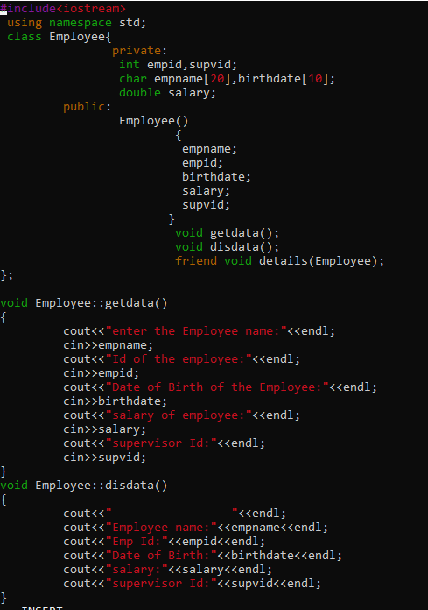

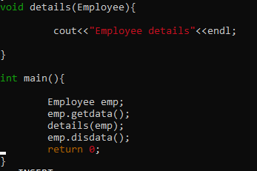

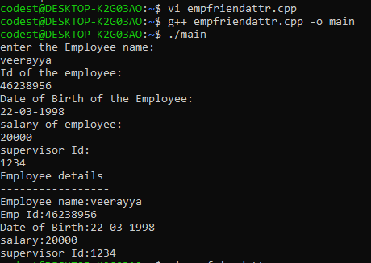

#include<iostream>

using namespace std;

class Employee{

private:

int empid,supvid;

char empname[20],birthdate[10];

double salary;

public:

Employee()

{

empname;

empid;

birthdate;

salary;

supvid;

}

void getdata();

void disdata();

friend void details(Employee);

};

void Employee::getdata()

{

cout<<"enter the Employee name:"<<endl;

cin>>empname;

cout<<"Id of the employee:"<<endl;

cin>>empid;

cout<<"Date of Birth of the Employee:"<<endl;

cin>>birthdate;

cout<<"salary of employee:"<<endl;

cin>>salary;

cout<<"supervisor Id:"<<endl;

cin>>supvid;

}

void Employee::disdata()

{

cout<<"-----------------"<<endl;

cout<<"Employee name:"<<empname<<endl;

cout<<"Emp Id:"<<empid<<endl;

cout<<"Date of Birth:"<<birthdate<<endl;

cout<<"salary:"<<salary<<endl;

cout<<"supervisor Id:"<<supvid<<endl;

}

void details(Employee){

cout<<"Employee details"<<endl;

}

int main(){

Employee emp;

emp.getdata();

details(emp);

emp.disdata();

return 0;

}